

Thank you for taking part in the UKESF Primary Electronics programme. We hope that you are able to give us your feedback via the short teacher survey sent to the email you used to register. It should take no longer than 10 mins and your thoughts help us to keep improving the programme.
We’d also love to hear how your classes found the project. We have put together some suggested tools for simple, whole class evaluation. Each tool should take around 15 mins or less and can be done at any convenient time and using minimal resources. You are welcome to choose the tool which works best for your class or to use all or a combination. When your class has completed their feedback, please email photos to education@ukesf.org, along with any comments the children make.

Mood Tree
Prep: print the tree outline onto A3 paper or draw your own simple outline. Cut out enough red, yellow and green leaves for your class, either using the sheet below printed onto A3 or by cutting coloured paper to a similar leaf shape.
Activity: ask each child to choose the colour that reflects their experience of the project – red for a negative experience overall, green for a positive experience and yellow for a mixed experience. Ask the children to write a word on their leaf to help explain their thinking. For example, a red leaf might say ‘boring’ or ‘hard’ or could pick out a particular part which they enjoyed the least; ‘arguing’ or ‘cutting out’. When they have written their word, they can stick it to the tree.

Colour-in mood characters, with thanks to the ASDC Explore Your Universe project
Prep: print the Explore Your Universe colouring sheet below (1 per child).
Activity: ask each child to choose and colour in the character which reflects their experience of the project. Children will also need to fill in the box to explain the character they chose. This can be using words or drawing. If none of the characters match their feelings, they can use that box to draw and explain their own character instead.

Emojis
Prep: Either print the emoji sheet below onto A3 paper or print enough A5 emoji worksheets for one per child.
Activity: explain what each emoji means. With the single, large sheet, give each child a sticker and ask them to stick it on the emoji that most closely matches how they felt during the project. With the worksheets, ask them to circle the emoji that most closely matches their experience and add a short comment explaining why.

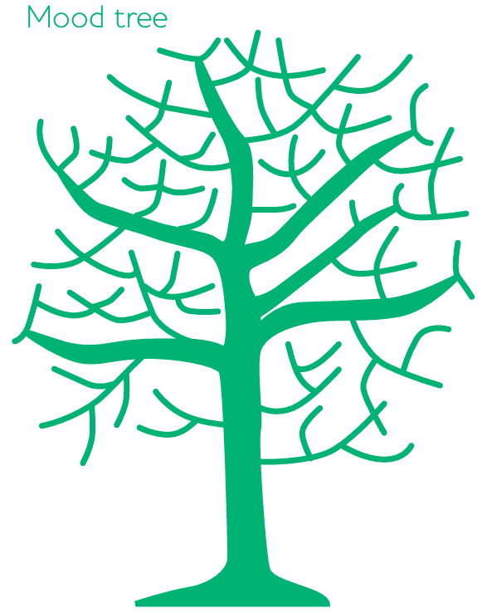

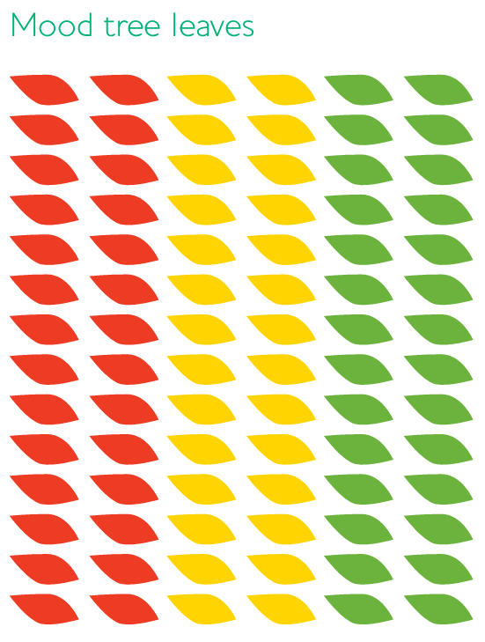
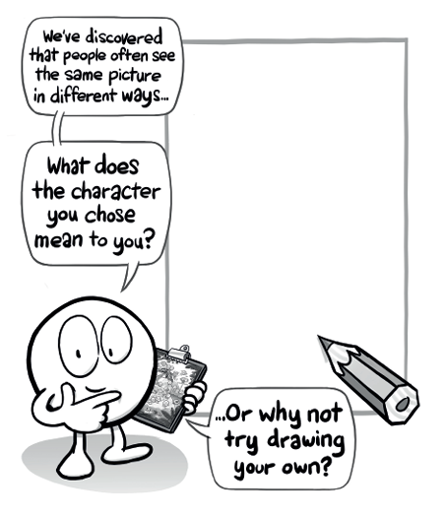
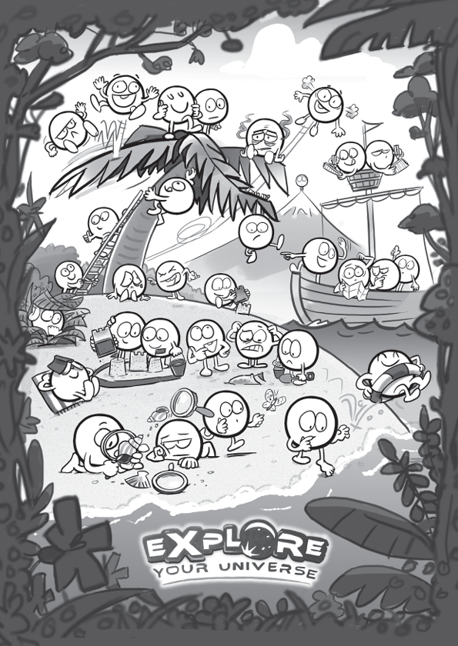
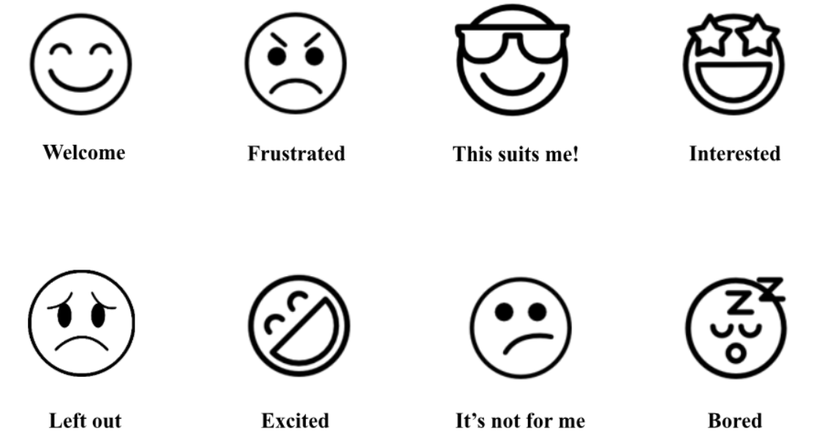
I chose this emoji because:

I chose this emoji because:

