CanSat Recommended Kit

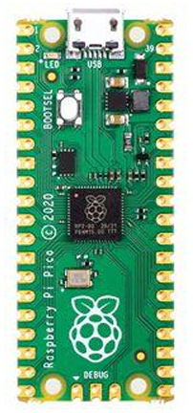
Raspberry Pi Pico
The Raspberry Pi Pico combines a small microcontroller with several hardware interfaces (UART, SPI, I2C) that have a large amount of configurability. USB programming support and a large memory make this an easy microcontroller to work with and is ideal for getting started with CanSat.

In this workbook we will install the Arduino framework onto the Pi Pico to allow the device to be programmed using the Arduino C# based language.

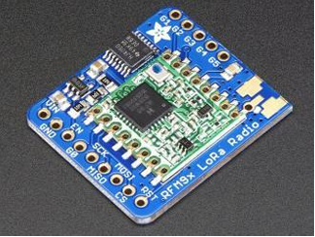
Adafruit RFM96W LORA Transceiver Radio Breakout - 433 MHz
The RFM96W is our communication device. It connects to the Raspberry Pi and allows messages to be sent via radio with a range of around 2KM line-of-sight. It comes in several available frequencies but 433MHz is recommended for UK use.

Antenna
The Adafruit RFM96W is provided without an antenna but either a 173mm wire can be soldered to the ANT pin or a SMA connector can be attached for connection to a larger gain antenna such as YAGII.

BMP280 Barometric Pressure/Temperature/Altitude Sensor
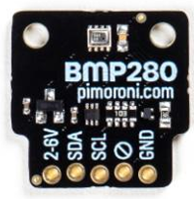
The BMP280 allows temperature and pressure to be read from a single sensor via the I2C interface.

Breadboard and wires
Breadboard and plug-in wires (male-male, male-female, female-female) for prototyping.
