CanSat Adafruit Feather Workbook
The following labs have been designed to introduce you to some of the electronics and programming skills that will be required to undertake the CanSat competition.

Contents
The Starting Kit 2
Lab 0: Setting up the Programming Software 2
Lab 1: My First Program 4
Lab 2: Hello World! 5
Lab 3: BMP280 Readings 6
Lab 4: Transmitting a message 9
Lab 5: External Power 14
Lab 6: SPI Comms: 15

The Starting Kit
This workbook assumes you have the Adafruit Feather M0

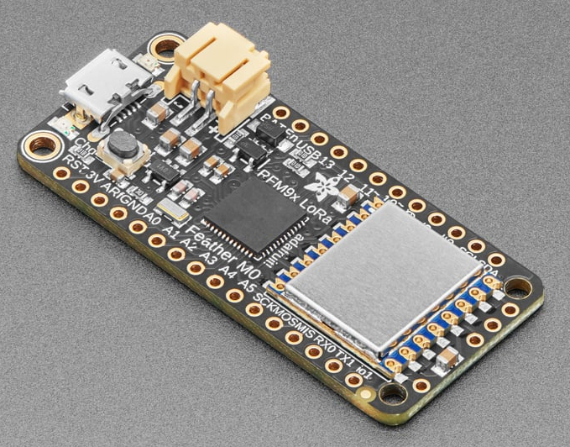
The Feather combines a small microcontroller with several hardware interfaces (UART, SPI, I2C) that have a large amount of configurability. USB programming support, large memory and an inbuilt antenna make this an easy microcontroller to work with and is ideal for getting started with CanSat.

In this workbook we will use the Arduino IDE, allowing the device to use Arduino C# based language.
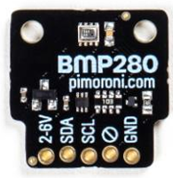
BMP280 Barometric Pressure/Temperature/Altitude Sensor
The BMP280 allows temperature and pressure to be read from a single sensor via the I2C interface.

Lab 0: Setting up the Programming Software
You will need to open the Arduino IDE. This will be where you will program and interface with the Feather M0.
Open this now. You should see a screen that looks something like this:

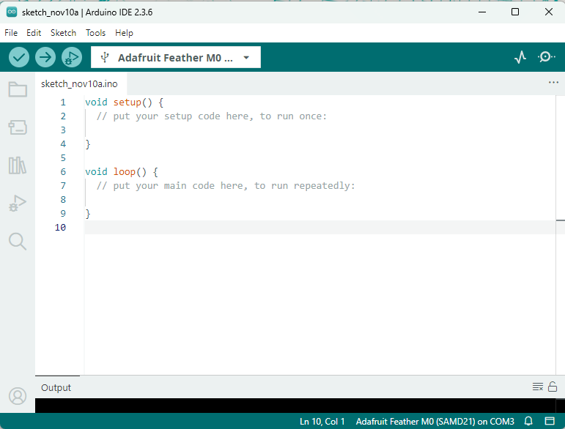

In order to work with the Feather in the Arduino IDE, you will need to follow the instructions on Arduino IDE Setup using the section titled ‘Installing via Arduino Boards Manager’.

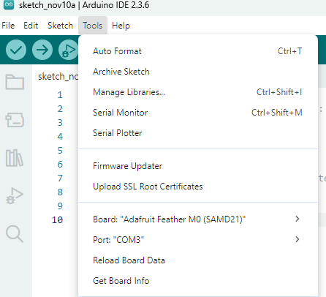
Then plug the Feather into your PC’s USB port. You will need to use:
Tools > Board > Adafruit SAMD Boards > Adafruit Feather M0 (SAMD21)
Then select the COM port for the device. You may need to plug unplug and plug in the device to see the COM port ‘appear’.

Lab 1: My First Program
In a new sketch, create the program below.

//1) Flash onboard LED
void setup() {
pinMode(LED_BUILTIN,OUTPUT); //Sets the onboard LED as an output
}

void loop() {
digitalWrite(LED_BUILTIN, HIGH); //Turns on the LED
delay(1000); //Waits 1s
digitalWrite(LED_BUILTIN,LOW); //Turns the LED off.
delay(1000);
}

Then, use the Upload button (the arrow) to put the code onto the Feather. After some time, you should see the light on the Feather begin to blink, 1s on, 1s off.

Explanation:
The Arduino framework uses two functions, called ‘setup()’ and ‘loop()’. When the board is powered on, ‘setup()’ is run, and then ‘loop()’ is run continuously until the board is powered down.

Whenever you want to use a pin (or ‘GPIO’, General Purpose Input/Output), you must declare its use in the setup function. In this case, we’ll use the on-board LED as an output. You can also access this pin by referencing 25 [eg. pinMode(25,OUTPUT);], rather than ‘LED_BUILTIN’, but this is clearer to someone reading the code!

Inside the loop function, we can turn the LED on and off by ‘writing’ HIGH or LOW to that pin. As we only want ‘on’ and ‘off’, digitalWrite (as opposed to analogueWrite) will be used.

‘delay’ is a useful function built into the Arduino language which will cause the Feather to wait a number of milliseconds before continuing to the next line of the code.

Lab 2: Hello World!
The Feather can communicate with the Arduino IDE if it’s plugged in, which can be very useful when receiving data from a sensor, so that the computer can deal with it.

The USB on the computer uses a serial data connection (Universal Serial Bus), so we’ll open a serial connection with the pi, and then write to it. Use the following program:

//2) Hello World (Serial Comms)
void setup() {
Serial.begin(9600); //Set up serial comms with a rate of 9600.
delay(1000); //Small delay to enable the setup
Serial.println("Starting test 3, Hello World!");
}
void loop() {
Serial.print("Hello "); //Prints without newline
Serial.println("World!"); //Prints to a newline.
delay(1000);
}

In order to monitor the serial connection, you will need to select the ‘Serial Monitor’ magnifying glass symbol in the top-right corner of the arduino IDE. You can change the baud rate (the 9600 chosen earlier) in the Serial monitor. Anything other than 9600 will look like a random mess as the communications will not work properly.
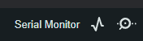

It is important with any devices the Feather interacts with to check that they’ve actually connected correctly, hence the ‘if (!Serial)’ statement. If the program attempts to use an unconnected Serial, the Feather will crash, but you won’t have any way of knowing that!

Additional tasks:
Can you get the Pi Pico to output a steadily increasing number rather than “Hello World!”? You will need to look up how to introduce a variable into your program.
Using the Arduino inbuilt functions, can you get the messages to include the current time or date?

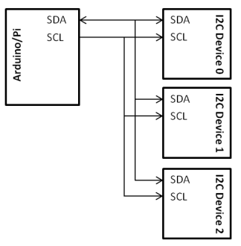
Lab 3: BMP280 Readings
A more reliable way to do temperature sensing is to use the BMP280, which can measure temperature and pressure, as well as calculate an altitude based on the current pressure.

It uses I²C communication (often written as I2C for simplicity), which allows several components to be connected to the same data cables.

We do need to use specific pins to access I2C. The default pins for the Feather are Pin 20 (SDA, Serial Data) and Pin 21 (SCK, Serial Clock). These are marked on the chip as ‘SCL’ and ‘SDA’

Connect the BMP280 to the Feather, connecting VCC to the 3V pin, GND to a GND, and SDA to SDA and SCK to Serial Clock. Using the BMP Sensor program should allow you to send temperature and pressure data to the serial connection. If you are reading ‘inf’ or ‘0’ for all readings, you may need to change the default I2C channel used by the code. Use the I2C scanner code to detect any connected I2C devices.

To do:
Make sure you monitor the Serial connection. If you haven’t connected the BMP280 properly, you’ll see an error on the serial output.

Can you use the ‘readAltitude()’ function to estimate the altitude?

Can you modify the program to printout Pressure to the nearest whole number, and temperature to 1dp?
BMP Sensor Code:

#include <Adafruit_BMP280.h>
#include <Wire.h>
Adafruit_BMP280 bmp; //Creates the 'bmp' object for the sensor.

void setup() {
Serial.begin(9600); //Set up serial comms with a rate of 9600.
bmp.begin(0x76); //Replace 0x76 with the relevant I2C channel

Serial.println("Starting test 5, Reading BMP Sensor.");
}
void loop() {
double Temp = bmp.readTemperature();
double Pres = bmp.readPressure();
Serial.println("BMP Reading:");

Serial.print("Temperature: ");
Serial.print(Temp);
Serial.println("C");

Serial.print("Pressure: ");
Serial.print(Pres);
Serial.println("Pa");
delay(1000);
}

I2C Scanner: (USE TO IDENTIFY CHANNEL FOR SENSOR)

#include <Wire.h>

void setup() {
Serial.begin (115200); //***** make sure serial monitor baud matches *****
delay(100);

while (!Serial);

Serial.println ();
Serial.print("SCL Pin: ");
Serial.print(String(SCL));
Serial.print(", SDA Pin: ");
Serial.println(String(SDA));

Serial.println ("I2C scanner. Scanning ...");
byte count = 0;

Wire.begin();
for (byte i = 1; i < 120; i++)
{
Wire.beginTransmission (i);
if (Wire.endTransmission () == 0)
{
Serial.print ("Found address: ");
Serial.print (i, DEC);
Serial.print (" (0x");
Serial.print (i, HEX);
Serial.println (")");
count++;
delay (1);
}
}
Serial.println ("Done.");
Serial.print ("Found ");
Serial.print (count, DEC);
Serial.println (" device(s).");
}

void loop() {}

Lab 4: Transmitting a message
To send a message using the inbuilt antenna and LoRa module, you’ll need to install the RadioHead library.

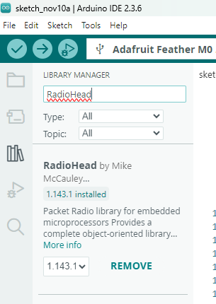
Press the library icon on the left hand side of the Arduino IDE, and type ‘RadioHead’ into the search bar.

You need to install the top package, ‘RadioHead by Mike McCauley’.

This module comes with a lot of in-built information ready for us to use.

Use the code on the next few pages to create a sender (and receiver for testing). There’s comments on the code to explain the specifics of the instructions.

When programming your own CanSat, it may not be able to reliably listen for a response. It could be worth transmitting only, depending on your missions.

Documentation can be found here:
https://www.airspayce.com/mikem/arduino/RadioHead/
More examples for transmission and receiving can be found here:
https://learn.adafruit.com/adafruit-rfm69hcw-and-rfm96-rfm95-rfm98-lora-packet-padio-breakouts/rfm9x-test

You Try:
- Can you transmit a message to your teacher?
(They’ll have to have the receiver program running!)
- Can you transmit the readings from the BMP280 to the teacher?

Code for Sender:

// BP Feather M0 Transmitter code

#include <SPI.h>
#include <RH_RF95.h>

#define RFM95_CS 8
#define RFM95_RST 4
#define RFM95_INT 3

// Change to specific other frequency, must match Receiver's freq!
#define RF95_FREQ 433.4

RH_RF95 rf95(RFM95_CS, RFM95_INT);

void setup()
{
pinMode(LED_BUILTIN, OUTPUT);
pinMode(RFM95_RST, OUTPUT);

// LED used to verify setup is complete.
digitalWrite(LED_BUILTIN, HIGH);

// manual reset
digitalWrite(RFM95_RST, HIGH);
delay(10);
digitalWrite(RFM95_RST, LOW);
delay(10);
digitalWrite(RFM95_RST, HIGH);
delay(10);

rf95.init();
delay(100);
while (!rf95.init()) ;

rf95.setFrequency(RF95_FREQ);
delay(100);
while (!rf95.setFrequency(RF95_FREQ)) ;

// Set antenna power. Maximum is 23
rf95.setTxPower(23, false);

digitalWrite(LED_BUILTIN,LOW);
}

int16_t packetnum = 0; // packet counter, we increment per xmission

void loop() {

char radiopacket[20] = "Hello World " + String(packetnum++);
radiopacket[19] = 0;

rf95.send((uint8_t *)radiopacket, 20);

rf95.waitPacketSent();

// Uncomment to add a 'wait for reply'
// uint8_t buf[RH_RF95_MAX_MESSAGE_LEN];
// uint8_t len = sizeof(buf);
// if (rf95.waitAvailableTimeout(1000))
// {
// // Flash if you received the message
// if (rf95.recv(buf, &len))
// {
// digitalWrite(LED_BUILTIN,HIGH);
// delay(1000);
// digitalWrite(LED_BUILTIN,LOW);
// }
// }
delay(1000);
}

Code for Receiver:

// BP Feather M0 receiver code

#include <SPI.h>
#include <RH_RF95.h>

// Define reserved pins
#define RFM95_CS 8
#define RFM95_INT 3
#define RFM95_RST 4

// Change to specific frequency, must match transmitter's freq!
#define RF95_FREQ 433.4

// Singleton instance of the radio driver
RH_RF95 rf95(RFM95_CS, RFM95_INT);

void setup() {
// Turn on LED to verify setup.
pinMode(LED_BUILTIN, OUTPUT);
digitalWrite(LED_BUILTIN, HIGH);

pinMode(RFM95_RST, OUTPUT);
digitalWrite(RFM95_RST, HIGH);

// Initialise Serial Comms.
Serial.begin(9600);
delay(100);
while (!Serial) delay(1);
delay(100);

Serial.println("Feather LoRa RX Test!");

// Manual reset
digitalWrite(RFM95_RST, LOW);
delay(10);
digitalWrite(RFM95_RST, HIGH);
delay(10);

// Initialise RF transmitter/receiver.
rf95.init();
delay(100);
if (!rf95.init()) {
Serial.println("LoRa radio init failed");
while (1);
}
Serial.println("LoRa radio init OK!");

// Set receiver frequency.
rf95.setFrequency(RF95_FREQ);
delay(100);

if (!rf95.setFrequency(RF95_FREQ)) {
Serial.println("setFrequency failed");
while (1);
}
Serial.print("Set Freq to: "); Serial.println(RF95_FREQ);

// Set antenna power (23 is maximum).
rf95.setTxPower(23, false);

// Turn off LED to verify initialisation is complete.
digitalWrite(LED_BUILTIN, LOW);
}

void loop() {
if (rf95.available()) {

// Message detected. Create buffer
uint8_t buf[RH_RF95_MAX_MESSAGE_LEN];
uint8_t len = sizeof(buf);

if (rf95.recv(buf, &len)) {
// LED On to indicate recieving
digitalWrite(LED_BUILTIN, HIGH);
RH_RF95::printBuffer("Received: ", buf, len);
Serial.print("Got: ");
// Print the buffer as a string.
Serial.println((char*)buf);
Serial.print("RSSI: ");
Serial.println(rf95.lastRssi(), DEC);

// Uncomment to send a reply
// uint8_t data[] = "And hello back to you";
// rf95.send(data, sizeof(data));
// rf95.waitPacketSent();
// Serial.println("Sent a reply");

digitalWrite(LED_BUILTIN, LOW);
} else {
Serial.println("Receive failed");
}
}
}

Lab 5: External Power
It is possible to power the Feather with an external power supply using a LiPo Battery and the side-bort. Use the Feather to create a flashing LED based on temperature readings from the BMP280.

You should make the LED flash faster if the temperature is higher, and slower if the temperature is lower. Example code is below, but should only be used if you cannot work out what to do!

//5) Flash on Temp, External Power Test
#include <Adafruit_BMP280.h>
#include <Wire.h>
Adafruit_BMP280 bmp; //Creates the 'bmp' object for the sensor.

int getDelay(double temp){
//Maps temperature from 10 to 30 onto an output of 200 to 2000
if (temp<10) return 200; //Prevent negative timings being provided
delayTime = (temp-10)*90 + 200;
return (int)round(delayTime);
}
void flash(int delayTime){
digitalWrite(LED_BUILTIN,HIGH);
delay(delayTime);
digitalWrite(LED_BUILTIN,LOW);
delay(delayTime);
}

void setup() {
if (!bmp.begin()){ //If the BMP doesn't start
for (;;); //Wait forever.
}
}
void loop() {
double Temp = bmp.readTemperature();
delayTime = getDelay(Temp);
flash(delayTime);
}

Lab 6: SPI Comms:
NOTE: This lab is only necessary if you HAVE AN SPI DEVICE. Please skip unless you introduce one.

The communications chip that is used by the CanSat project uses SPI communication (Serial Peripheral Interface). It’s similar to I2C, but uses 4 pins rather than two.

In order to work out which pins we need to use for the communication chip, run the following code:

void setup() {
Serial.begin(9600);
}

void loop() {
Serial.print("MOSI: ");
Serial.println(MOSI);
Serial.print("MISO: ");
Serial.println(MISO);
Serial.print(" SCK: ");
Serial.println(SCK);
Serial.print(" SS: ");
Serial.println(SS);
Serial.println();
delay(5000);
}


Default code for the ground stations:

// BP Feather M0 receiver code

#include <SPI.h>
#include <RH_RF95.h>

// Define reserved pins
#define RFM95_CS 8
#define RFM95_INT 3
#define RFM95_RST 4

// Change to specific frequency, must match transmitter's freq!
#define RF95_FREQ 433.4

// Singleton instance of the radio driver
RH_RF95 rf95(RFM95_CS, RFM95_INT);

void setup() {
// Turn on LED to verify setup.
pinMode(LED_BUILTIN, OUTPUT);
digitalWrite(LED_BUILTIN, HIGH);

pinMode(RFM95_RST, OUTPUT);
digitalWrite(RFM95_RST, HIGH);

// Initialise Serial Comms.
Serial.begin(9600);
delay(100);
while (!Serial) delay(1);
delay(100);

Serial.println("Feather LoRa RX Test!");

// Manual reset
digitalWrite(RFM95_RST, LOW);
delay(10);
digitalWrite(RFM95_RST, HIGH);
delay(10);

// Initialise RF transmitter/receiver.
rf95.init();
delay(100);
while (!rf95.init()) {
Serial.println("LoRa radio init failed");
Serial.println("Uncomment '#define SERIAL_DEBUG' in RH_RF95.cpp for detailed debug info");
while (1);
}
Serial.println("LoRa radio init OK!");

// Set receiver frequency.
rf95.setFrequency(RF95_FREQ);
delay(100);

if (!rf95.setFrequency(RF95_FREQ)) {
Serial.println("setFrequency failed");
while (1);
}
Serial.print("Set Freq to: "); Serial.println(RF95_FREQ);

// Set antenna power (23 is maximum).
rf95.setTxPower(23, false);

// Turn off LED to verify initialisation is complete.
digitalWrite(LED_BUILTIN, LOW);
}

void loop() {
if (rf95.available()) {

// Message detected. Create buffer
uint8_t buf[RH_RF95_MAX_MESSAGE_LEN];
uint8_t len = sizeof(buf);

if (rf95.recv(buf, &len)) {
// LED On to indicate recieving
digitalWrite(LED_BUILTIN, HIGH);
RH_RF95::printBuffer("Received: ", buf, len);
Serial.print("Got: ");
// Print the buffer as a string.
Serial.println((char*)buf);
Serial.print("RSSI: ");
Serial.println(rf95.lastRssi(), DEC);

// Uncomment to send a reply
// uint8_t data[] = "And hello back to you";
// rf95.send(data, sizeof(data));
// rf95.waitPacketSent();
// Serial.println("Sent a reply");

digitalWrite(LED_BUILTIN, LOW);
} else {
Serial.println("Receive failed");
}
}
}

Antenna setup:
If you are making your own antenna, you can use the following guide. This isn’t necessary with the Feather’s, as they have a pre-soldered coil-antenna.
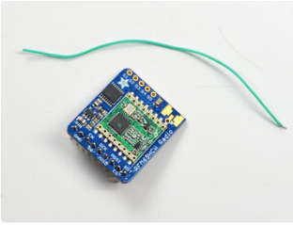
A wire antenna, aka ‘quarter wave whip antenna’ is low cost and works very well! You just have to cut the wire down to the right length.
Cut a stranded or solid core wire the proper length for the module/frequency
433 MHz - 16.5cm
868 MHz - 8.2cm
915 MHz - 7.8cm

You want to use a wire that is ¼ of the wavelength you are transmitting on, using this formula:

