

Build A Bot: Additional Information for Teachers
Thank you for your interest in the Primary Electronics: Build A Bot programme. We look forward to meeting your class in an online session soon!
This document is designed to give you some additional information about the programme. If you have any questions that aren’t answered here, please get in touch via education@ukesf.org.
Programme Aims:
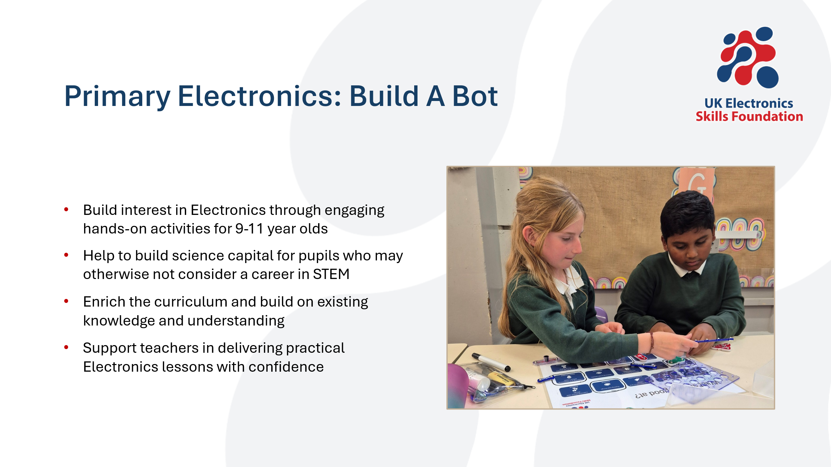
Resources:
A box of equipment will be sent to the school address you provided.
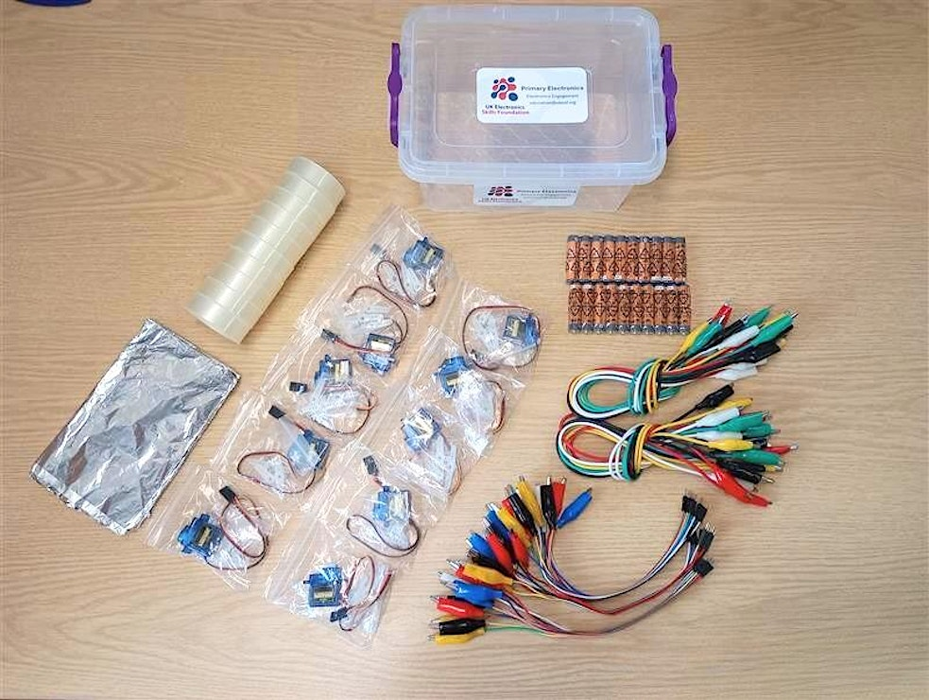
You will also need coloured pens/ pencils, scissors, 10 micro:bits with battery packs and 10 laptops or tablets for the children to use to code their bots.
All the digital resources, including a slide deck and teacher notes for each session, can be downloaded from our website, using the link in your confirmation email. If you have not received this link, please let us know and we can resend it to you.
The equipment is mostly reusable and can be used with future classes, making the programme repeatable. If you need any additional components (ie, if you would prefer children to work in pairs), we have provided a list of where we bought everything on the resources page. An additional 10 sets of equipment will cost around £35-40.
Timeline:
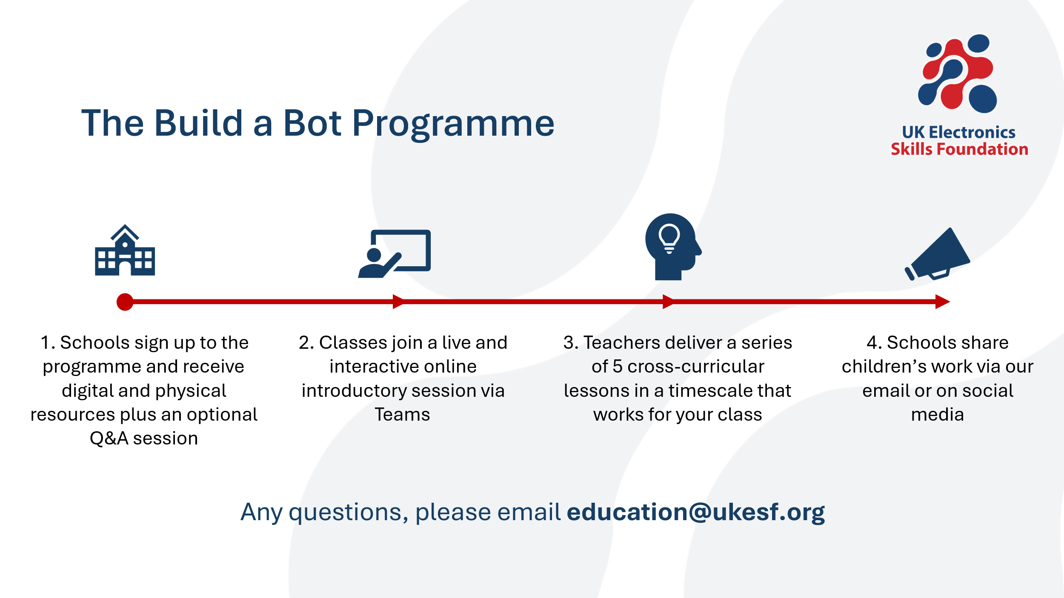
Our last direct contact with you and your class is step 2, then it’s over to you!
The 5 lessons can be combined or split up into smaller sessions. They can be taught in a block, as a special activity (eg, Science Week or after SATs) or fitted in with a normal timetable, for example teaching the coding lesson in your timetabled computing period. The programme is designed to fit flexibly in a way that works for your school.
The STEM Attributes:
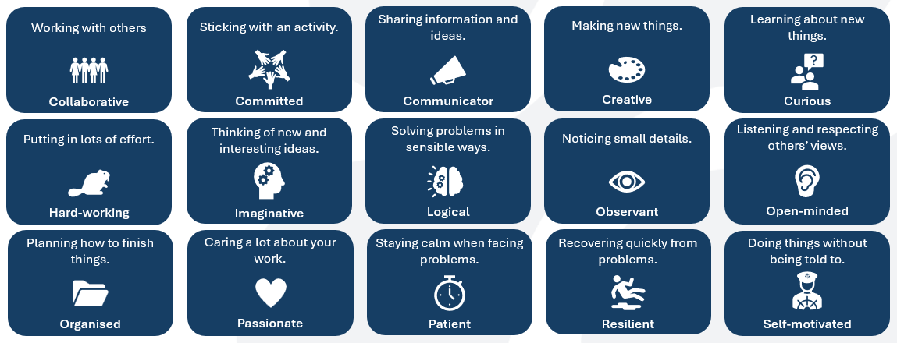
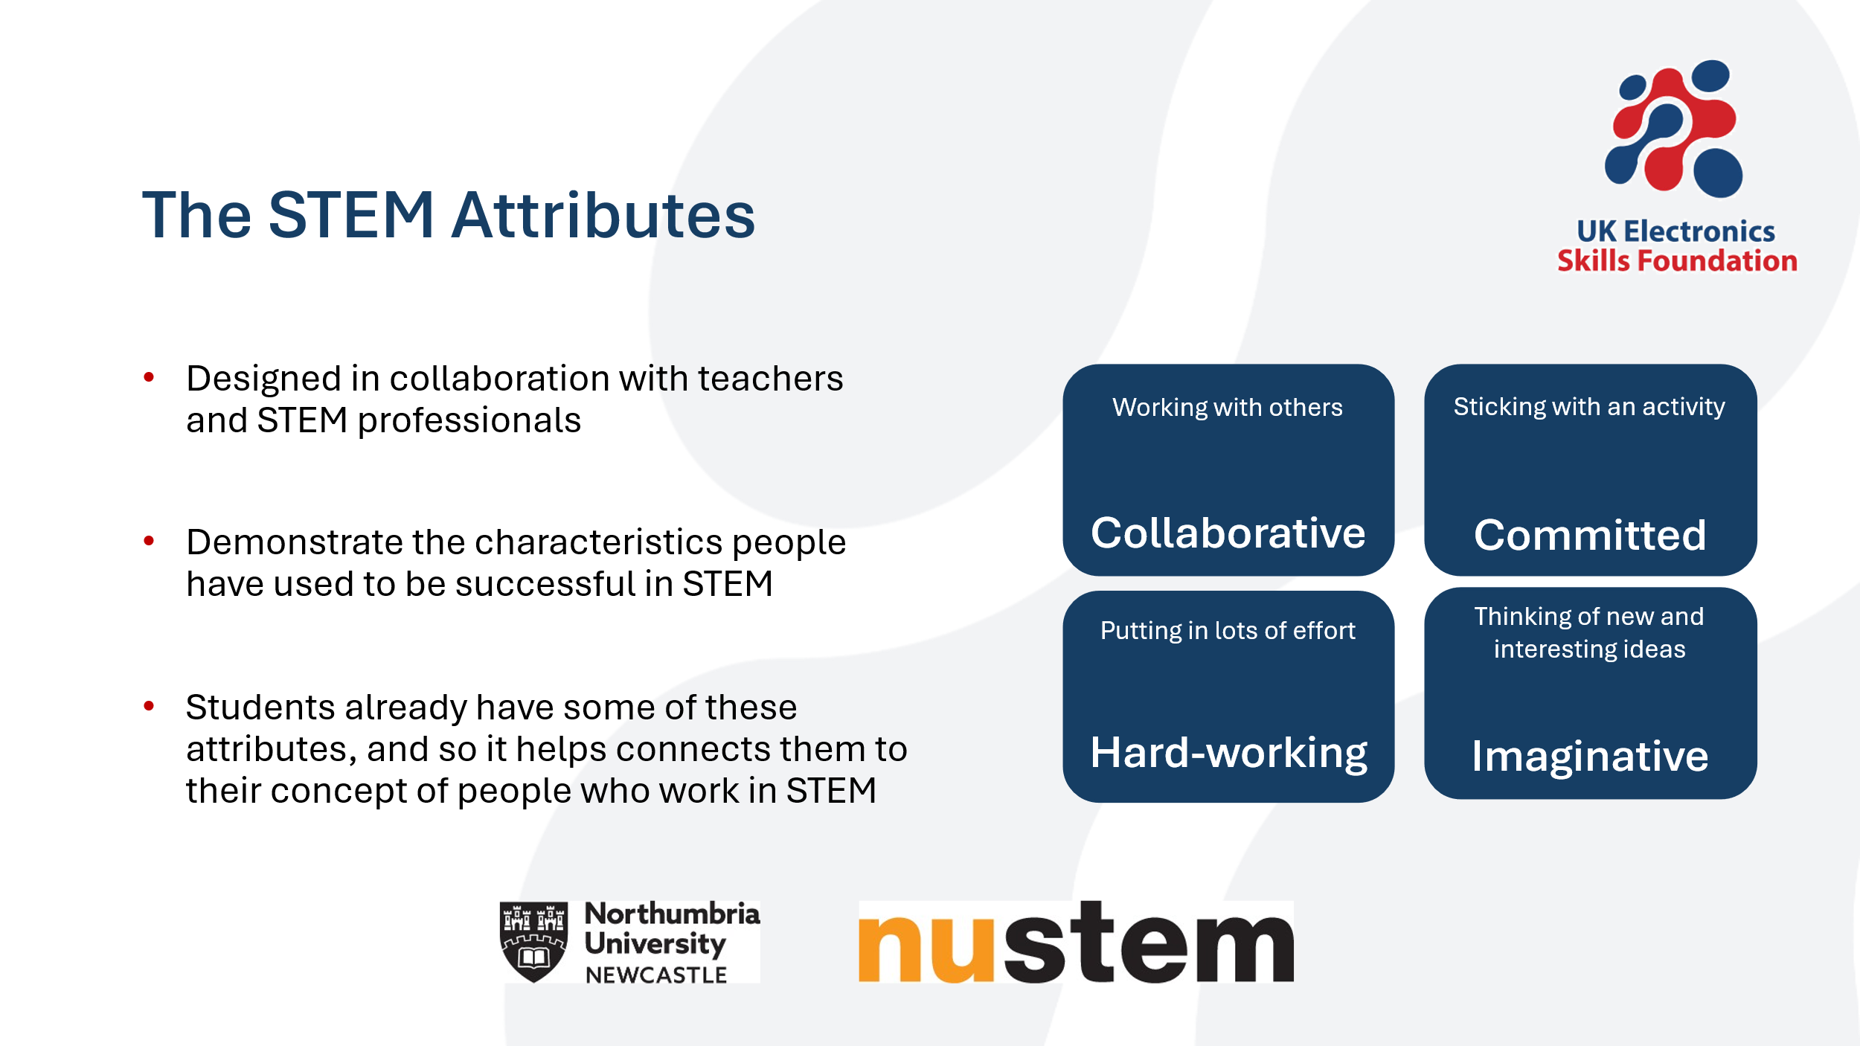
The Sessions:
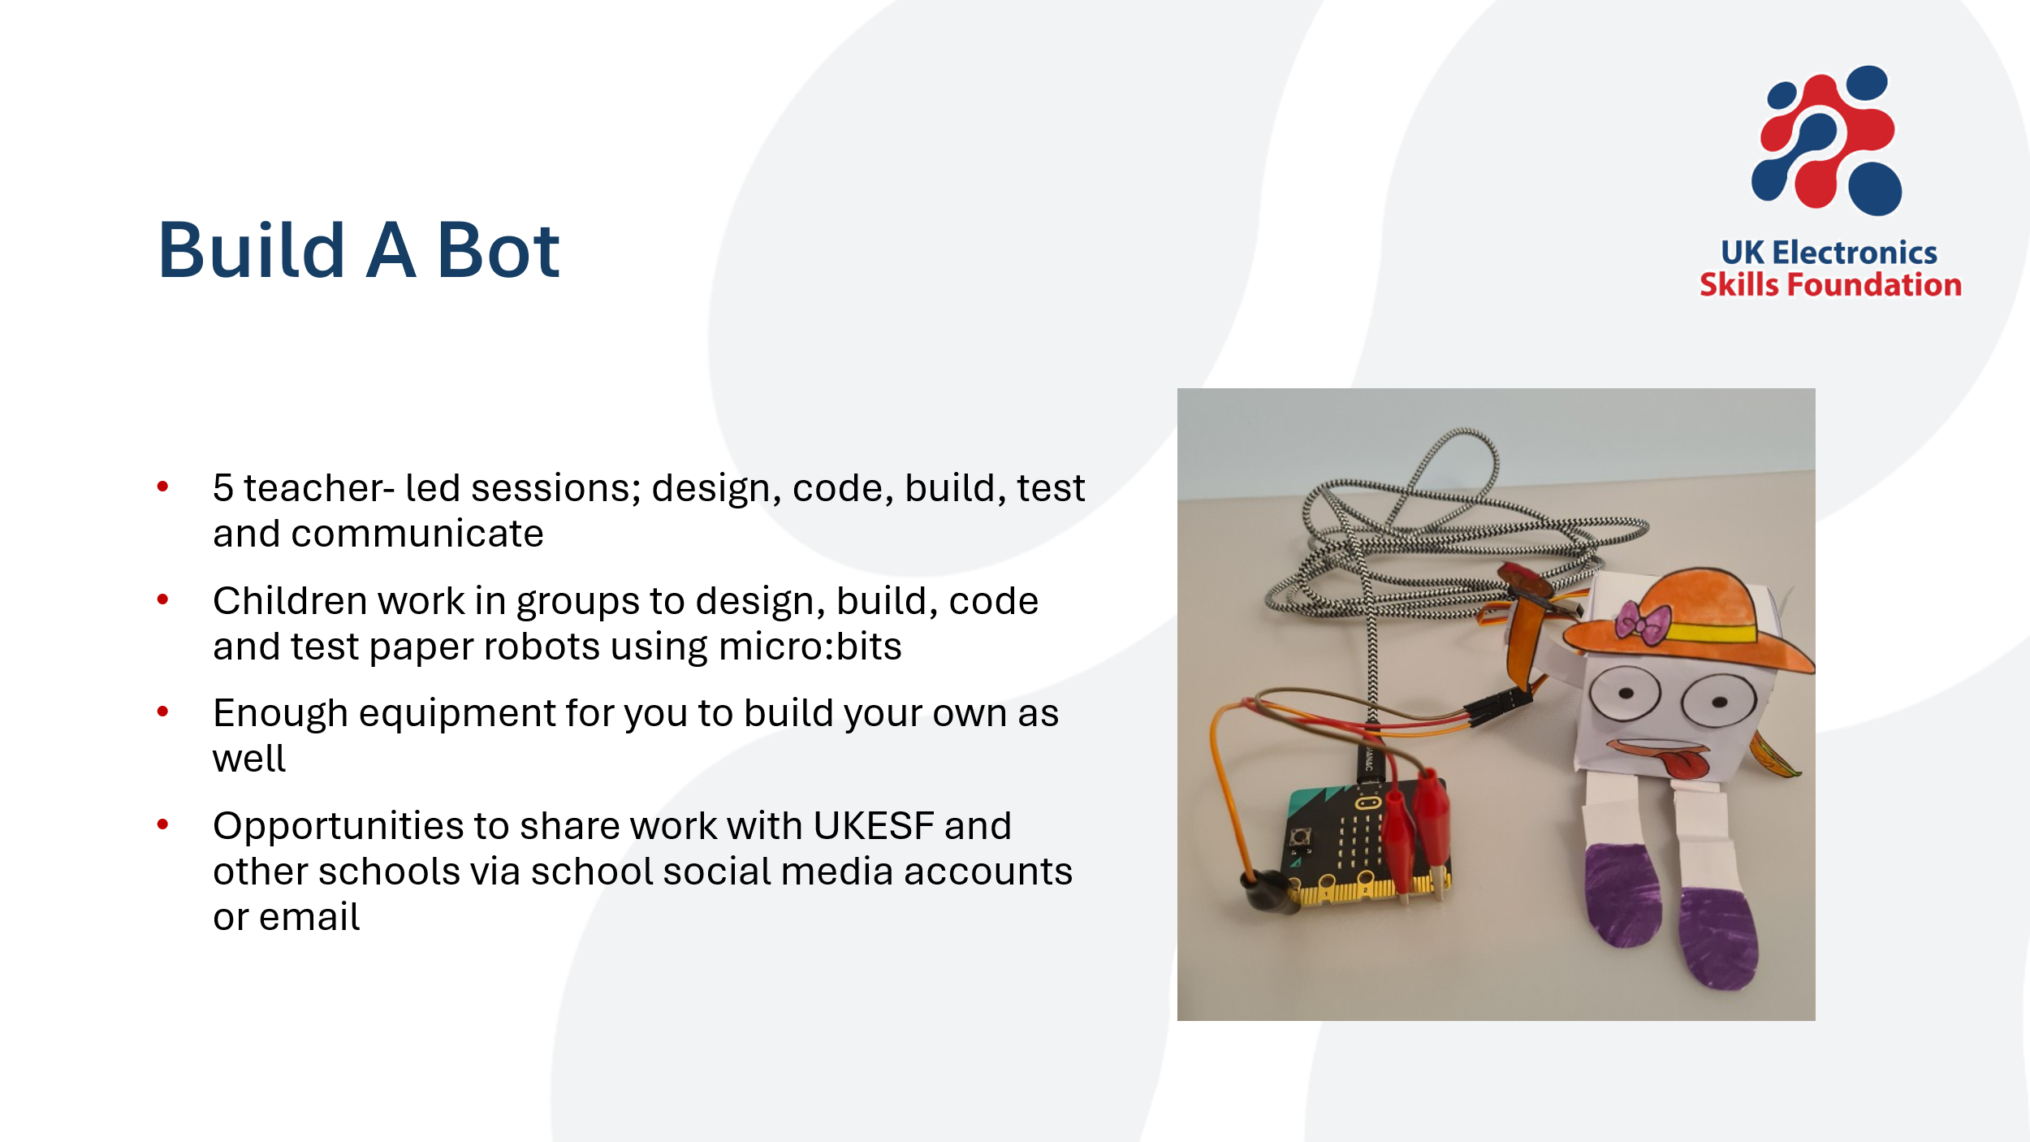
We suggest that the children work in mixed ability groups of 4. As the project is cross-curricular, this gives everyone a good opportunity to take on different roles in the group, including supporting each other.
We strongly suggest you have a go at building your own bot before doing these activities with your class and there is enough equipment provided so that you can do this.
All our activities have been tested with multiple teachers and classes, who report easy to follow instructions, even where teachers and students have no experience with electronics at all. However, we are always keen to improve our programmes and love to hear your feedback. We’ll send a short survey and we’d really appreciate you taking the time to tell us what you think. The feedback form is designed to take an absolute max of 10 mins to complete.

- Session One: Design
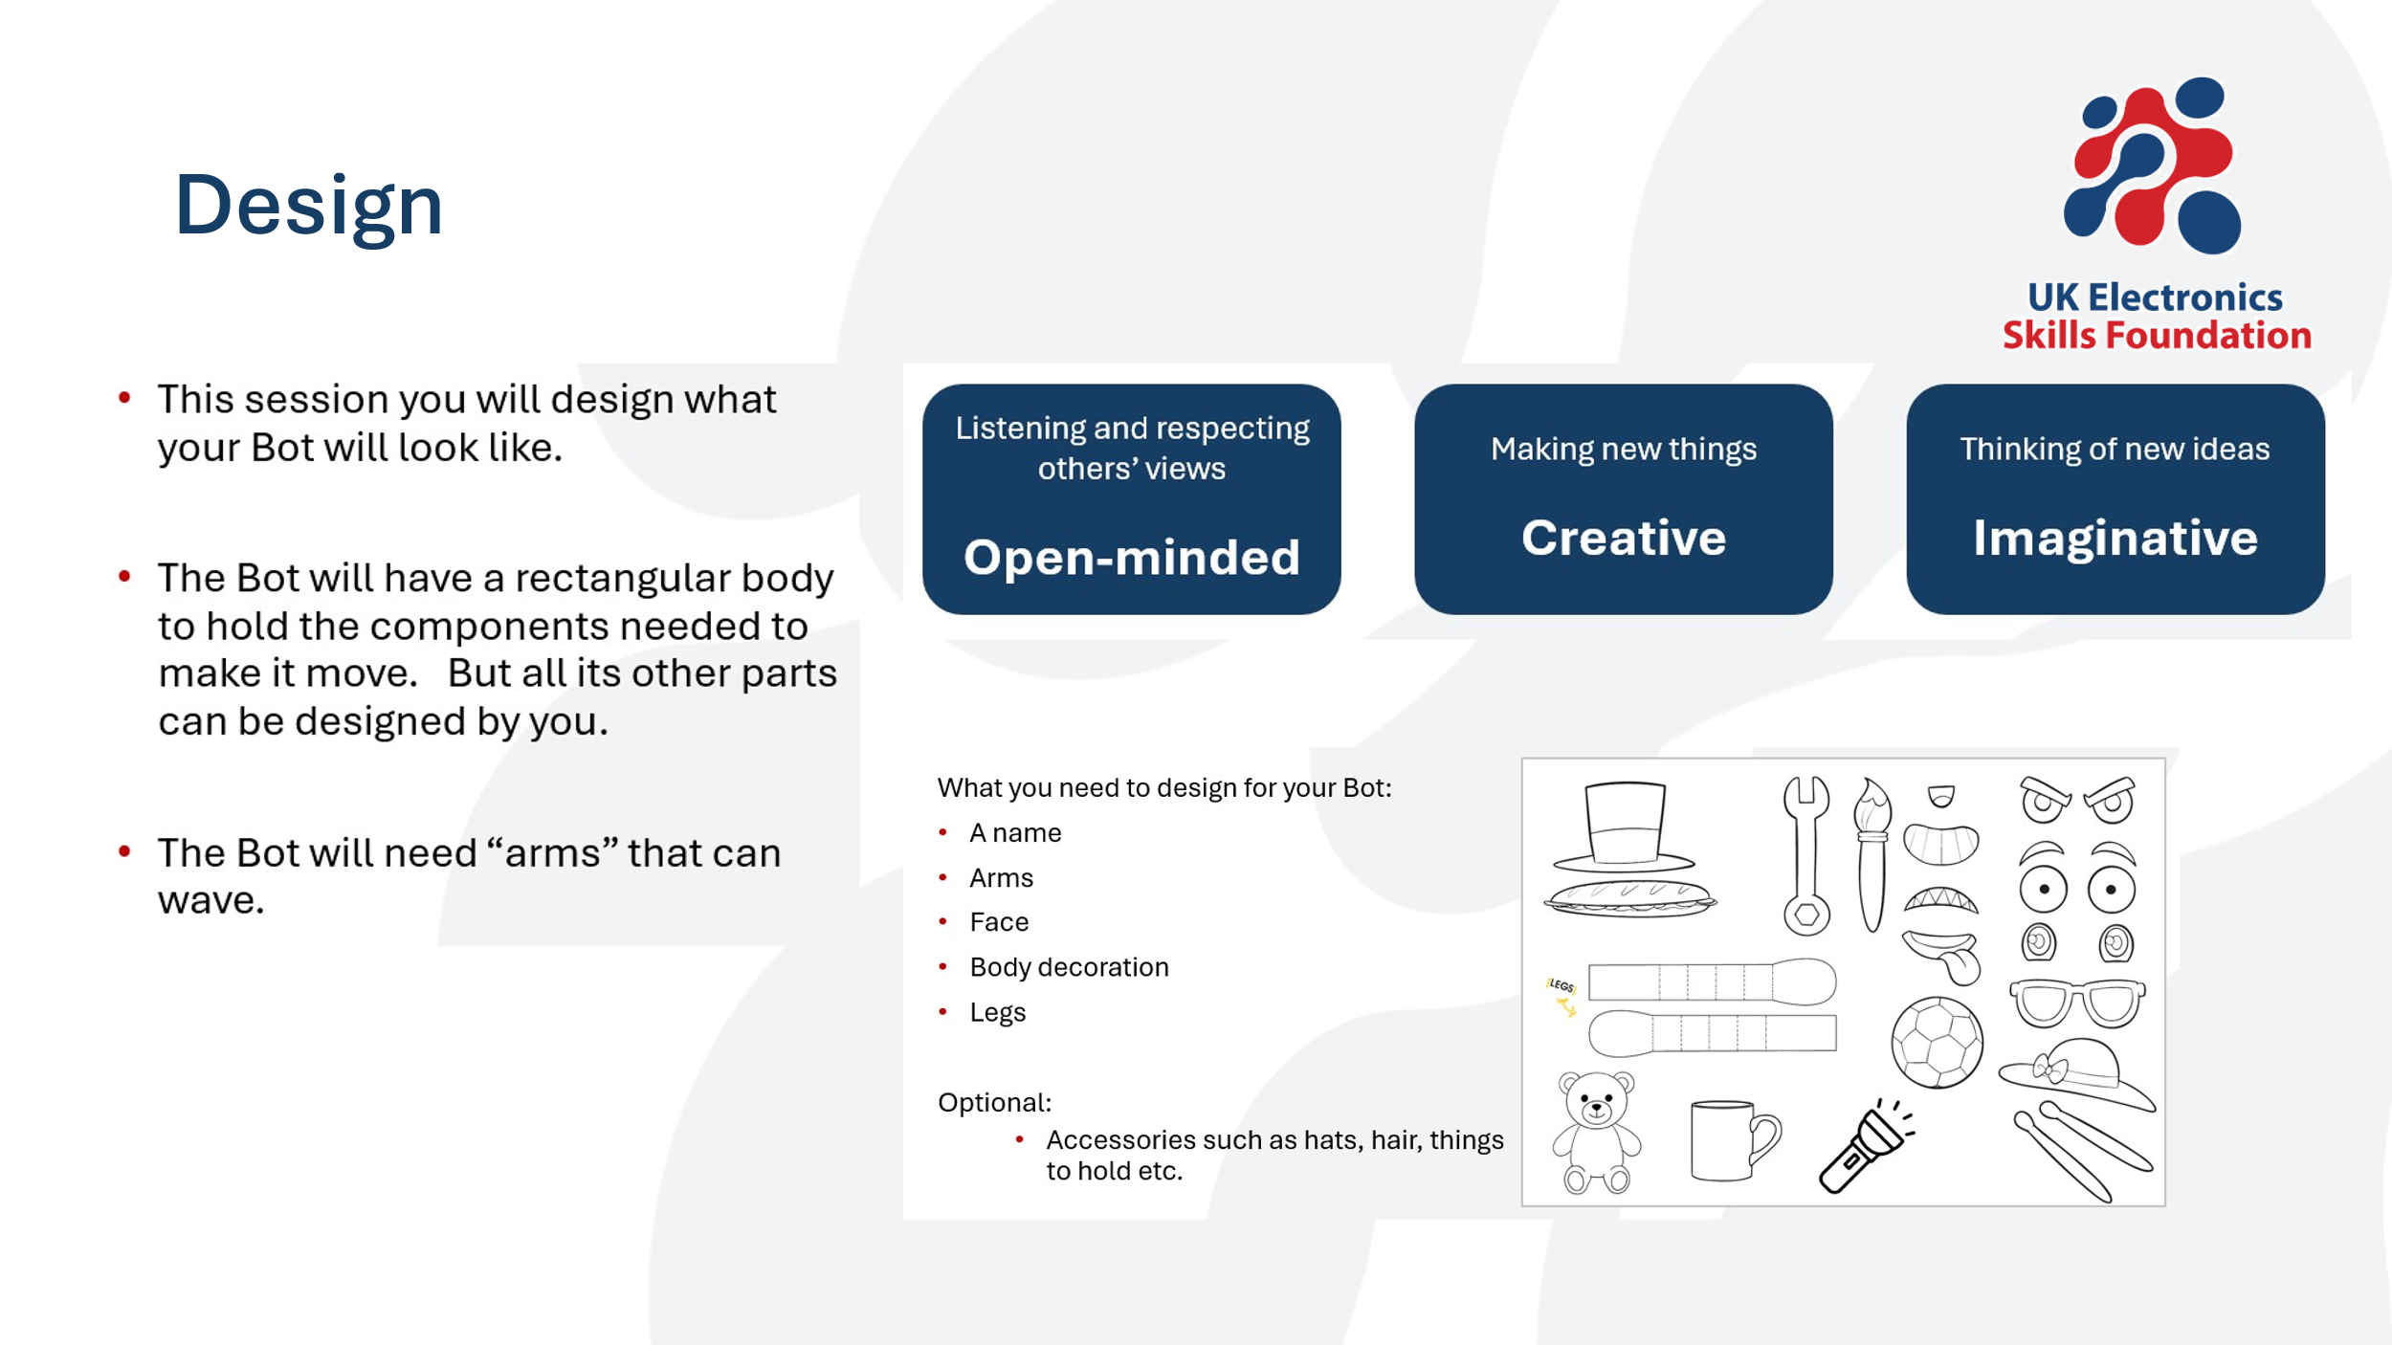
The first session is very simple – each group will work together to decide what their bot will look like. Each set of slides is designed to walk your class through every step.
Firstly, there’s a broad intro to what they’ll be doing in that session, then a focus on the particular skills they’ll need to use. In this case, being open-minded, creative and imaginative. We suggest that adults in the classroom do their best to spot individuals and groups using these skills and give positive feedback to reinforce the skills focus.
Each slide deck then goes on to a more detailed step-by-step of exactly what groups need to think about and what they need to produce by the end of the session.
Do bear in mind that groups will need to keep their work safe from session to session. Depending on your class, you may want to collect in their work or have a designated place in the classroom for it to be kept between sessions.
- Session Two: Code
All of this section has been written by a Computer Science teacher and extensively tested, so we’re really confident that it works. The slides are designed to go in small steps so that it’s easier for teachers to troubleshoot by comparing children’s code to the code on the slide at every step.
Though it looks like a lot of content, it’s quite quick for the children to do each step. The online block editor is simple and mostly intuitive to use. Groups will move through the steps more quickly as their confidence grows.
It can be helpful to print these slides as a handout booklet for groups to follow so that they can work at their own pace and also look back more easily at previous slides to troubleshoot their code.
Some common mistakes that groups make; forgetting to remove blocks they are not using, mistyping info in boxes, forgetting to click ‘run’ to see the emulator work or forgetting to download their new code to the micro:bit after making a change.
Once their final code is saved to a microbit, it’s a good idea to name the micro:bit with a sticky label, ready for the next session. This is particularly important if you decide to split the coding section over several lessons.
If groups need to edit their code in later sessions (eg, if their testing shows something isn’t working the way they thought it would), the online micro:bit editor will save their code under the project name they’ve given. It will only save on the device they’ve been using though, so it’s easiest to have groups swap round devices so that everyone has the one with their code saved.
If you think this will be an issue for your school (eg, if cookies on devices are regularly deleted) then you can create logins. You can do this for each group but it’s most simple to create a class login, use that for all the groups and make sure that they each create a named project. We also have a working copy of the code, so do get in touch if you need it!
- Session Three: Make
This session uses lots of fine motor cutting and sticking skills, so we’ve included some options to simplify some parts if needed. If you know cutting out is an issue for any of your groups, you may wish to consider colour photocopying their design sheets so you have a back up option if needed.
Groups will test the arms moving before closing their bot body, so you’ll need to have their programmed micro:bits available from the previous session.
- Session Four: Test
This session may be shorter if all your groups have been working at a similar pace. If not, this is a good opportunity for any groups that need to catch up to finish their coding or building.
If you have a group that moves through testing very quickly as well, they can either do multiple tests or there are some extension options they could try as part of this session (including a ‘ticklebot’, which uses tin foil on the bot’s legs to allow it to respond to touch). All the instructions for this are in the final slide deck.
- Session Five: Communicate
The final session focuses on communicating their work; an important skill that people working in STEM need to use to be successful!
You can link this to anything that you are currently working on or use it as an opportunity to be creative. A poster is a simple and accessible way to communicate what they’ve done but there are so many possible options.
The notes in the slide deck suggest some ideas but you really can use whatever suits your class best. You may want to link it to the particular kind of writing you’re currently focussing on. For example, groups could write an acrostic, a magazine article or a set of instructions. You could draw in a Working Scientifically skill, such as a labelled diagram or photos. You could have each group contribute to a larger whole-class output – a floor book or class display – or you could let the children decide how to communicate what they’ve done, either completely independently or from a list of options you provide.

After the Project:
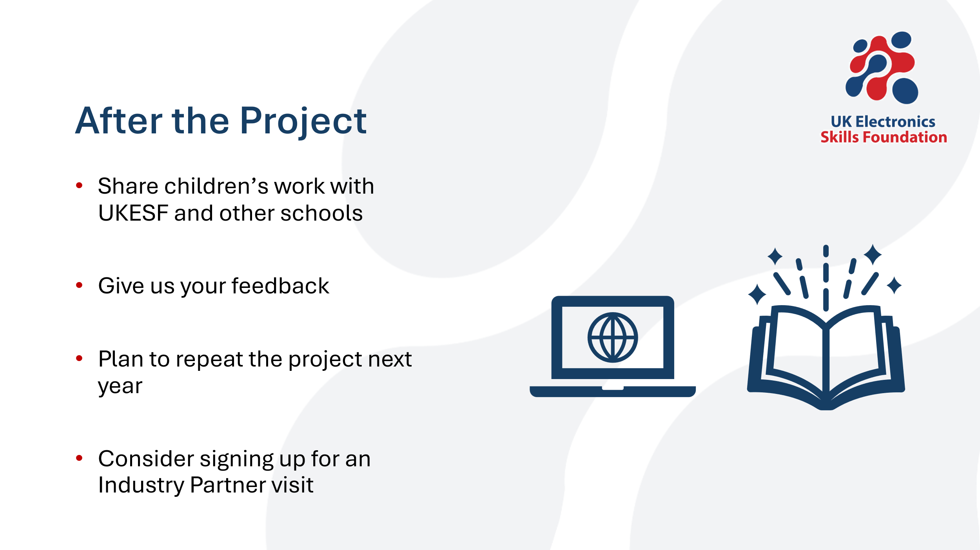
We’d love to see the work your classes have done. Share it with us via email or social media - education@ukesf.org or share on socials and tag us. We’re @UKESF on Instagram, UKESF – UK Electronics Skills Foundation on Facebook or UK Electronics Skills Foundation (UKESF) on LinkedIn.
Do think about how this set of lessons could fit into your usual yearly planning. All the equipment is reusable (though you might need more batteries/ foil/ tape) and we’ll continue to provide support.
We also offer a version of this programme where an industry partner from a local business visits your school to deliver a 1-hour hands-on workshop which replaces the live online introduction. This is only currently available in a few areas of the UK. You can find out more and sign up via our website (ukesf.org/what-we-do/primary-electronics/) or by emailing education@ukesf.org. If this programme is not yet available in your area, we will add your details to our waiting list and let you know once we have a local industry partner.
We really appreciate the time you’re giving to help inspire young people in your class about electronics. If you have any questions at all, please do get in touch via education@ukesf.org.

